CISA’s Zero Trust Maturity Model
Charity Dube
Security Auditing and Assessments

Table of Contents
Abstract……………………………………………………………………………………………3
Development of Zero Trust Model …………………………...……………………………...…...4
Goals of the Zero Trust Model………...……………………………………………………….….5
IT and Cybersecurity Departments’ Role in Achieving Zero Trust...…...………...…....……...….5
Audits and Assessments Help Achieve or Measure Compliance.…………………………………6
NIST 800-207………………………………………………….….………………………………6
Challenges of the Zero Trust Model…………………………....…………………………………7
Value of Zero Trust Model……………………………………...…………………………………7
Conclusion……………………………………...…………………………………………………8
References…………………………………………………………………………………………9

Abstract

Zero Trust is a framework in Cybersecurity that moves away from traditional perimeter-based methods and moves towards a verification and authentication method. It is a security strategy that is based on zero trust and assumes every request is a breach or attack. This paper serves to provide information on the origin of Zero trust, the goals, and key foundations of this approach. The paper also highlights the importance of Zero Trust in IT and Cybersecurity departments and how distinct roles apply the method to their everyday jobs. There are also challenges that organizations face with the implementation of Zero trust. Even with challenges, the Zero trust approach is valuable in the modern cybersecurity world especially with cloud-based environments and work-from-home jobs. Zero trust offers enhanced security and additional continuous monitoring.

Keywords: Zero Trust, compliance, risks, threats, frameworks, verify, authentication
CISA’s Zero Trust Maturity Model

- The events that led to the development of the Zero Trust Model started before 2004 during the perimeter-based approach. This approach was a security approach for decades, but there were faults in the system. The faults caused the conception of zero trust, in 2004, the idea was proposed. “Jericho Forum members saw potential problems with the perimeter defense approach and developed a new concept of security they called deperimeterization. The concept called for multiple levels of security controls, including encryption and data-level authentication” (Pratt,2022).
In 2010, the Zero Trust model was brought to fruition by a researcher, John Kindervag.

He felt that organizations should not trust anything inside or outside of the perimeter. In 2011 Google's initiative BeyondCorp promoted the usage of the Zero Trust model by enabling their remote workers to use VPNs. As the model kept evolving the core pillars of the model were created in 2018. In the same year, the SP 800-207, Zero Trust Architecture, was released by NIST, which contained the guidelines and core components of zero trust. A year later, Gartner introduced the terms zero-trust network access (ZTNA) and a networking model, Secure Access Service Edge (SASE). Both these terms were to add to the defense and were part of the framework.

As the pandemic meant, remote and hybrid work was on the rise. This gave way to the huge traction of zero trust, because security needed to be increased in 2021. Zero trust grew in the federal and private sectors.

- The Zero Trust Model has several goals that it was created to meet as a framework. The first goal of the Zero Trust Model is to verify and authenticate users and devices. Irregularities need to be assessed, and the framework sets standards for attempts to log and analyze such irregularities. The other goal is to monitor the network for malware. Another goal is to reduce attacks and disruptions for legitimate users to navigate networks. The goal is to apply strict access controls to protect data and eliminate trust. It is a Zero Trust goal to increase security by reducing the attack surface by granting users only access needed to perform necessary functions. The foundation goal is to verify all users and devices and assume no trust inside and outside of the network. Verification needs to be continuous, and network activity to minimize threats and detect attacks.
- The role of IT and Cybersecurity departments in achieving Zero Trust is especially important. IT and Cybersecurity departments are the main drivers of the Zero Trust model, collaboration is needed for this model to be maintained. Network Engineers are needed for network segmentation to enforce access controls. IAM specialists implement Multi-Factor Authentication (MFA) and Single Sign-On (SSO) for the management of user identities, access, and verification. Cybersecurity analysts minimize attacks by continuous monitoring, threat detection, hunting, and risk reduction. Compliance experts make sure that security and trust policies are followed. Data Security Architects play a role in achieving Zero Trust by creating frameworks that protect sensitive data in different environments.

- Audits and assessments help achieve or measure compliance in the zero-trust model because policies need to be followed, maintained, and adhered to. The following images show the governance of the zero-trust model by audit and assessments.

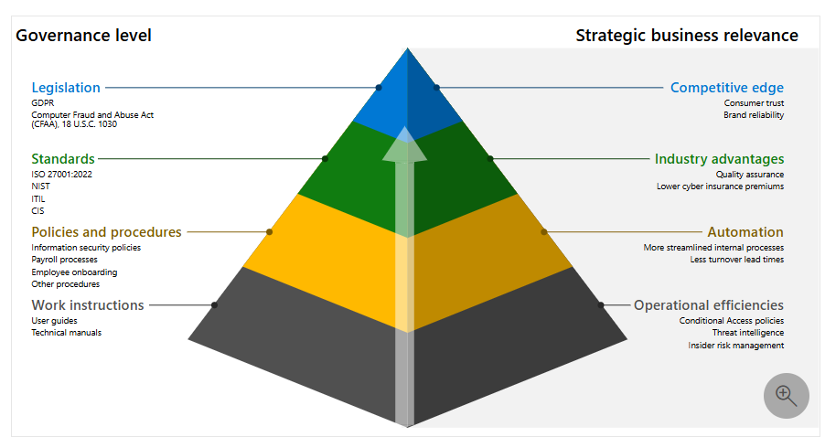

- NIST 800-207 shapes the framework and fundamentals of the Zero Trust Model. The best practices and steps to comply with NIST 800-207 are;
- Categorize and identify data and information.
- Create foundations for security controls to protect sensitive information.
- Conduct risk assessments to improve baseline security controls.
- Write down all the security controls in a framework document.
- Launch security controls in the organization's system.
- Track performance and measure the impact of the security controls once the controls are rolled out.
- Challenges when moving to the Zero Trust Model include the complex nature of hybrid networks. Integrating legacy systems with the Zero Trust Model presents costly challenges. The integration is also complex because most legacy systems are not designed to accommodate Zero Trust. The other challenge is the strain on resources, as implementing Zero Trust costs a lot of money and employee resources. Data used for Zero Trust can be a lot for legacy systems. “Without advanced analytics and automation, organizations may struggle to make sense of this data and have trouble rapidly and effectively responding to potential threats” (Tadmor,2024).
- There is value in the Zero Trust Model as organizations move to cloud-based assets, remote workers, and Bring Your Own Device (BYOD) environments. Cloud–based, remote, and BYOD environments will find value because Zero Trust ensures access to the cloud by remote workers from any device provided there is application and verification. Identity and Access Management (IAM) helps with secure login regardless of the location. The Zero Trust Model has continuous monitoring which is huge value for cloud-based remote workers. Continuous monitoring from the zero-trust model offers ongoing threat detection and risk management. The additional layer of security of Zero Trust works well with VPN’s and authentication adds value for remote workers.

Conclusion

The Zero Trust approach is new and has evolved over the years. The evolution of zero trust is mainly because of the restriction of traditional perimeter-based methods. Modern day cybersecurity threats and attacks have become some advanced that trusting methods does not work. Zero Trust Model verifies and authenticates users and devices and has a framework to analyze irregularities. The approach never trusts but requires that there should always be verification. “Instead of believing everything behind the corporate firewall is safe, the Zero Trust model assumes breach and verifies each request as though it originated from an uncontrolled network” (Microsoft, 2025).

References
Magazzo, S. (n.d). What is Zero Trust Architecture? Definition, Tips, and Strategies. Mondo.
https://mondo.com/insights/what-is-zero-trust-architecture-definition-tips-strategies/
What is Zero Trust? (2025, February 27). Microsoft.
https://learn.microsoft.com/en-us/security/zero-trust/zero-trust-overview
Pratt, M.K. (2022, October 12). The history and evolution of zero-trust security. TechTarget.
https://www.techtarget.com/whatis/feature/History-and-evolution-of-zero-trust-security
Tadmor, E. (2024, September 6). Overcoming the Challenges of Zero-Trust. Security Boulevard.
https://securityboulevard.com/2024/09/overcoming-the-challenges-of-zero-trust/
(2024, March 27). Understanding NIST 800-207. Riskrecon.
https://blog.riskrecon.com/understanding-nist-800-207

Picture References
Meet regulatory and compliance requirements. (2024, April 24). Microsoft.
https://learn.microsoft.com/en-us/security/zero-trust/adopt/meet-regulatory-compliance-requirements

